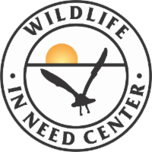
W349 S1480 S. Waterville Rd, Oconomowoc WI 53066
www.helpingwildlife.org 262-965-3090
Wish List
Donations are critically important to our life-saving efforts for the wildlife patients in our care. Be a part of our important work by donating items from our Wish List. Thank you!
Nut Meats (unsalted) Whole Nuts (unsalted)

Hulless/No Waste Bird Seed Mixed Wild Bird Seed

Sunflower Bird Seed Millet Bird Seed

Earthworms, Redworms, Waxworms, Flavored and unflavored Pedialyte
live Mealworms and Crickets And generic Pedialyte

Artificial Plants and Trees Laundry Detergent (liquid only)

Exam/Nitrile Gloves (small to extra-large) Paper Towels

Pillowcases without ruffles Cotton Balls

Canned fruit – no sugar added Postage Stamps

Canned Vegetables- preferably no salt added Pens, Scissors, Binder Clips, White-out

Rodent Block – pelleted complete Standard Size Folders & Hanging Folders
food for rodents

Washable Bed Incontinence Pads Printer Paper and Card Stock

Kleenex/facial Tissues

Our amazon Wishlist can be seen here:
