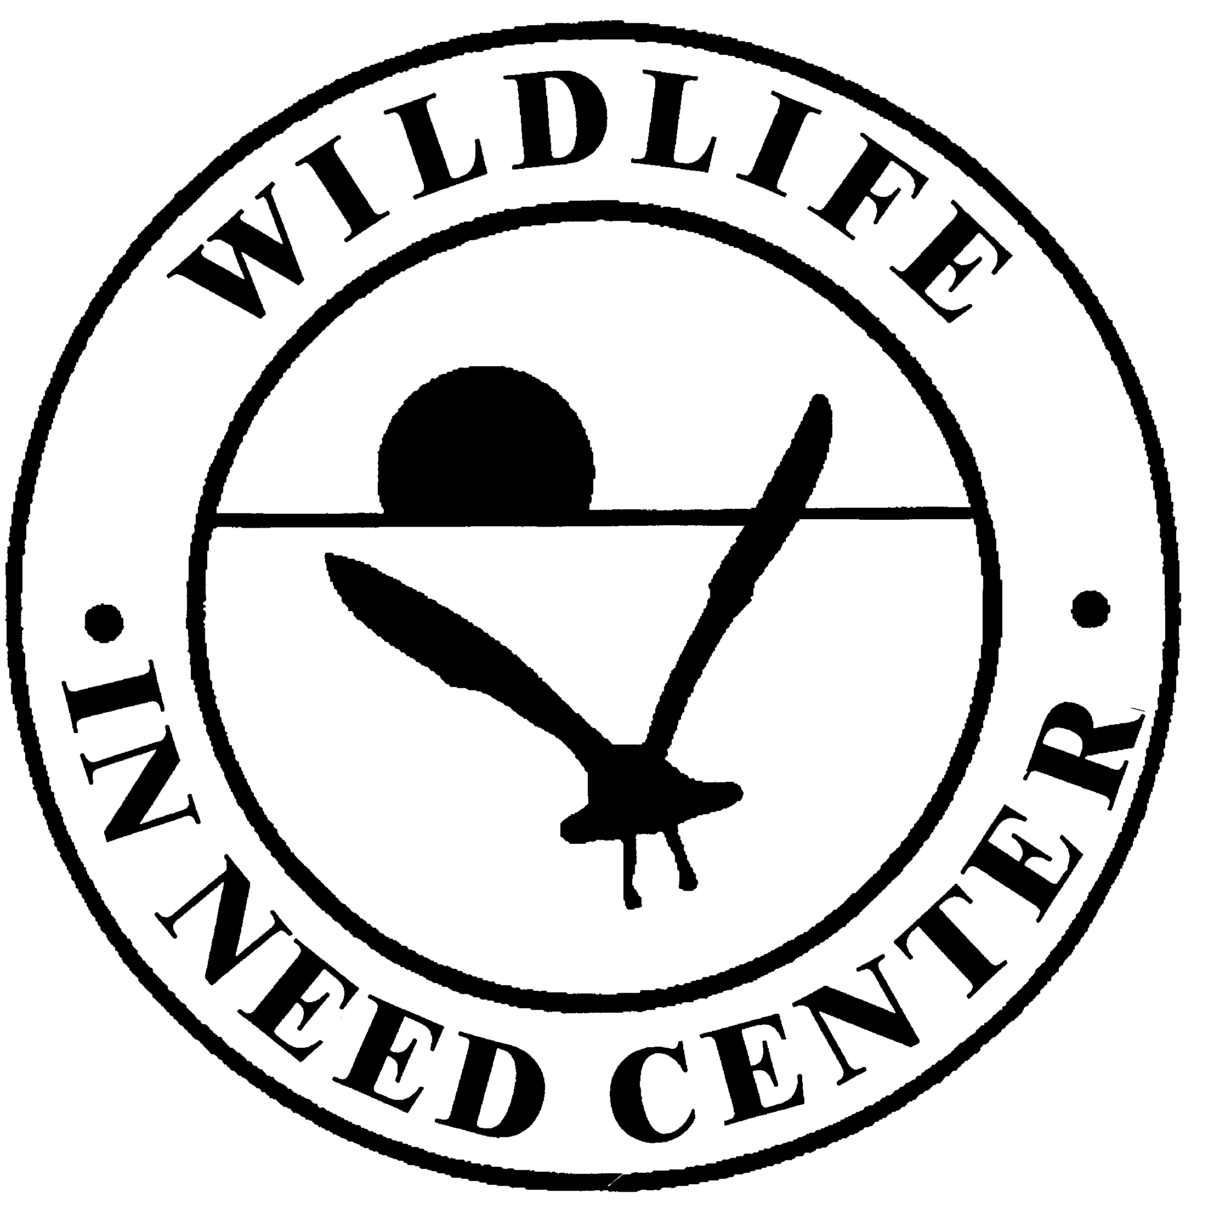
The Wildlife In Need Center Animal Admission Instructions
During the COVID-19 Pandemic
Please follow the instructions below based on your situation:
Did you call in advance and have an appointment?
If YES:
- Please place the entire box/container in which the animal is secured inside of one of the stainless-steel cages. Please do NOT remove the animal from your box/container. During the COVID-19 pandemic we are unable to return transportation containers or any contents inside of your container.
- Ring doorbell to alert staff that the animal has arrived.
- After ringing the bell, you may leave. Staff will be out to retrieve the animal shortly AFTER you have left.

If NO:
- Ring the doorbell to alert staff you are here.
- Staff will come to talk to you through the window to the left of the front door.

